Check your Open Badge(s) quality!
based on the Cities of Learning activity

Digital Open Badges capture essential information about learning and achievements by storing this metadata inside the badge image. A badge description tells a badge viewer about specific learning and achievement that a badge represents..

Watch the video for an explanation: https://youtu.be/_XsOR2EPVC4

Validate your Open Badge(s) quality with your team, earners and consumers! (mark ☑):

Review your Open Badge(s) description and confirm that you included the following data in the badge description. In case you are creating badges, make sure you have it added to the badge description (use text input boxes for making badge description)

Name of a badge:
Public link to a badge (if created and accessible):

Badge description includes the context of an achievemenet
Where and when did specific learning happen? What new knowledge, skills or change has happened as a result of learning? What kind of specific achievement was reached?

Badge description includes tasks completed
What did the badge earner complete to qualify for this badge? What roles or activities did the badge earner undertake? What evidence did the badge earner submit to claim this achievement?

Badge description includes assessment procedures
Consider involving your partners or potential badge endorsers at a certain point. They can give you valuable ideas or build a foundation for a wider recognition of the skills acquired through your programmes.

(optional) Badge description includes explanation of what new opportunities badge earner will unclock
What new opportunities does this badge lead to? Mention all the valuable things that this badge unlocks.

(optional) Badge description refers to a specific skills, competences and qualification framework
Though this information can be included as a separate data field in the badge, it does not hurt to mention if this badge shows any skills that are part of a larger competence framework or education standard or connects with a specific level of education

(optional) Badge description includes time spent to achieve a badge
This information is important because it gives information about how long has been ‘worked’ to achieve this badge. If a person worked 3 hours or 6 months to achieve the badge, that makes a difference.

(optional) Add any other data which can increase value of a badge
You can include any other relevant information about badge earner’s achievement which may increase value and trust in a badge.
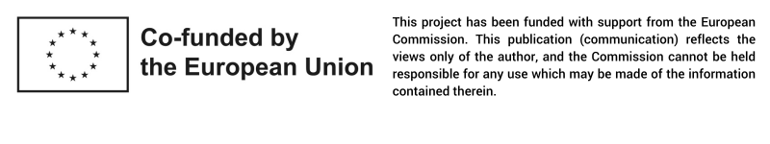

Bage consumers are people and organizations, e.g. employers, other sector representatives, social and professional contacts, who will get access to earned badges and will make their sense about learning, skills and achievements represented by a badge.

